Rolationshlps creating succoss

**Downe**

#### Project Area

###### Hom.al Train Station

Homai Train Station - Inspection and Test Plan

lns,.ni."on,IT•nCocl•o:

#### Activity Title Location A•flf

OfQ,n,}-ffMoMpr:

AT,roJ.,nM,,,..pr.

OanTrol!!!!!!_

W ,,...,N,.I

###### Boulnc:PadGroutln1

DN1212•ITP..01S

###### 19/12/202'

!111 - -of••Po11"'""°"''°'"',,_,"""'""'"°'"""p11•""•·

Ill ln.p.rt!.n In p,,o<on th.ck,wo,tt procnd" ..cor<I t dleci W1.qu11od. IW]W MN 1Mpe<tkwolabowftllti'4<I0111Jloonclto<onlod. ecordtobofllod. IHJi<.W

ONl:hoJ.,a(ft(l,_r,

GrantWallu•

12l5599-SP03-ST-l1SO- PROPOSED ACCESS II.AMP• SITOVT

J2l5599-SP03·ST-l200- PROPOSED ACCESS RAMP- EXISTING PIER l OITAJLS J2l55'9•SPOHT-]201- PROPOSED ACCESS fl.AMP• EXISTING PIER 2 DITAILS 32JSS9 1-SP03-ST-J202• PROPOSED ACCESS RAMP·EXISTING PIER 2 DETAILS J2JS5"·51'(1l•ST•l2SO• PROPOSED ACCESS RAMP-ABllTMEITT DETAILS- SHEffi l2l5599-5P0l-ST-l2Sl • PROPOSED ACCESS RAMP-ABUTMENT BEARING

O,awlftl'lll•f•,.r,n0eal111011U:

NZSllO<l:Spedll tlonforContreteProductlon KZS l109:19'7Conc1eteCon,tructlon NZSl101:Conaete5truchrres51arubrd

NZSl12l:5pedflatlonfvrMethodsoflestforConcrete NZSlll,:Spedflatlon1lorConcreteSurbcefln"hes

s,..dfko1L. :IApplC•7•6-2'·1•7•AC•TKhSp«.-Geo&Strvc

tt"em"l

St1ond•rd,Drawl111

ConstNctlonAnlvltyorM•tul•lflem•nt orSp,ednotlon ltd,r.ne,

ConnructlonAnlvltyD.. mptlon,Te,tlyp,, andAcceptanuerltert.a

Te1tfr.qu,ncy QAlte<ord

VerlflatlonM,thodand OnSlt.R.1pondbllltle1

DNZit.pSl1n

•ndD•te

#### l IPRELIMINARY & GENERAL

MelhodStatement

0.-.,elopment&S..letyAn•lysls

TheDownerSt•ncfud,(TDS)

Dtafn1lnnr I fn1lnnr,it.pl De1l1nerRepl

/

l

MethodSmement&JSEACompleted&slanedbv ***V.LA***

fJ4,71

re!cv•nt•uthodty

*!J!l9l;*

/

## *Zll/t)- '"'*

ConflrmatlonofsuperstructureJKHlllon.

#### 2 IMATERIALAPPROVALS

SlcnedlTP

l235599-SP0l·ST-3200 • PROPOSED ACCESS RAMP­ [XJSTING PIER 1 DITAILS.

32355,,·SP0l-ST·l20l•PROPOSEOACCESSRAMP·

£XISTINGPIER2D£TAILS l2l5599·SP0l·ST•l2D2•PROPOSEDACCESSRAMP-

SlgnedlTPrequhodfortheposltlonolthe1uperitructurebefo1e51ou1lng.

SlanedlTP

MOS,

lnElgltRel

��w . ·

7 *·u*

, - 7

7

-

*Z£ft2!/z*

* *1¾'-l1M'1*

## *&_;,"/P/ C/*

*/t f#'/'*

*-r*

NonShrlnkG,outApp«w•1

l235599•5P0l·ST-32S0- PROPOSED ACC!SS RAMP• AIUTMENTDITAllS-SHEffi l235599·SP0l·ST·l252 • PROPOSED ACClSS RAMP·

ApplC•74i-2'·847·AC·Te<hSpec-Gro&St,uc Sp«,•C0602.lD.O.

Non shrink grout •Mk.I 212 HP tobesubmllled todffli:n.-r forrevlew,nd •pp,ov•1ult

obtalmlSMp,t1htt2SD.ays>SOMp,1uperl252-Notel.4

*Ci.{rffJ67*

# *Zo/M*

*Ct4tV*

# *067*

�'

l2lSS99·SPOl·ST·3252•PROPOSEDACCESSRAMP­ A8UTMENT8EARING-Note

As p,,r J2355!1!>-SP0l·ST·l252 • PROPOSED ACCESS RAMP- ABUTMENT BEARING - Note

1,4, Glau Plate trlal to be undertaken to replk•1e bc•rlng sYd footprint of 210mm x 230mm x 20mm. Afn b to be poured prior lo Installation of bc•rlng grout to tonllrm voiding It less th•n 10% ol ueo. Undertaken with MSQA ob.er,,•llon,

Methodology to be submlttNI p!IOf to commcnccmcnL,

Once

SlleOb.er,,•tlonlleporl Wrltten•tccptanceofmaterl•lfollowlngtrl I.

3A-1

---.,:...

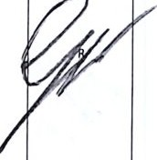

Acco«llnstoMDSiheetforSlkalllHP, Sffbelow,1r01.1t\o i.e•lcdwlthllm

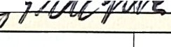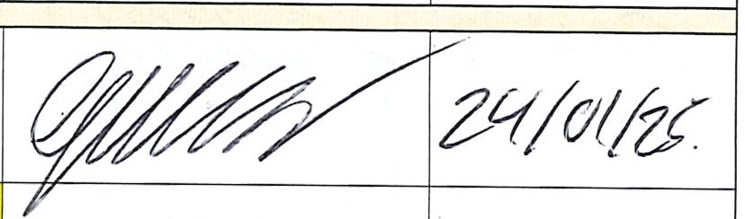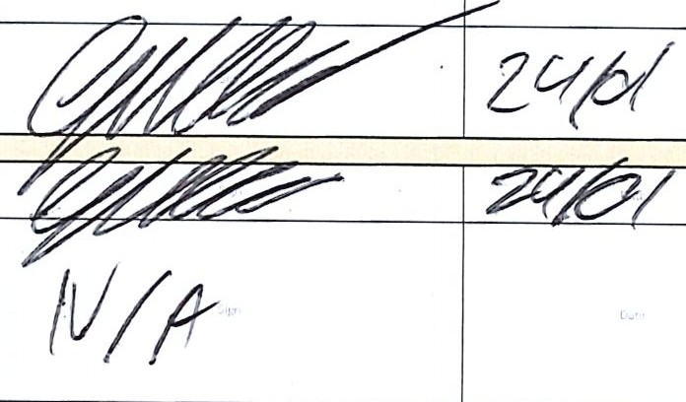

* + hutter, lelt 10 cure within ,mall ihul!e, •nd then ueatO'd with Slh Anti Sol u per d•ta iheetanachO'd•••

*f-*

***/t{t1lf/***

ClJRJNG TREATMENT

## *C/tC(,,,.tr/2*

##### Formwork should be left In place for at least 5 days ir

Mol

C11rln1M•lhod

App lC • 746-2·"8-47-AC ·Techs ·G= & Sltuc I possible, to prevent moisture evaporation and provider

*ft--f'1U-i*

rcstr.ilnt to edrty age hdrdencd exp;msion. Once fom,•

t

work Is removed a sultablc curing membrane such a Si Antlsol• should bo applied to •my exposed faces.

*c*

Rcrer to scp.sratc data 5hcct for further Jnformatlori't

l'llol

*f-t iAvt 01,*

###### I CONSTRUCTION ACTIVITIES

l2JSS99-Sl'Cll- :c = N.CESSRAMP• l

*414 r/4!!l- 4/*

Fo,1Nllonolcomtrucllonjdntrao.._..., *on:=.•/*1bi.tlr!Mn1IO11M «>mlrutdon/olr>t ,,,.,,.1

lllSS99-SPCll-ST-l10l - "110"°51:D ACCUS RAMP- EXJSTINGI No r•lnfo,cln1r•qul<•m<1ntl.

MSCASV

Groulln1Pr•·l'outln1 «lon

### A;>p

JIIElllD£TAICi

IC•7... 24-647·AC•TocnSc,K-GaoC.Suuc

CMdc10•nW1•lhltlhewrfocehprep d,und•rncl•or1H,•rlne1UC1lllnl<DfrH;t'°"llonp,lor10I [adlSll"uctun pourlnc.Nomlnal20mmwll1Hi pourl<I.

Pr••PourCMddllt

IU/4,f,/

Cor,aei.tot>apour•du ,,. ,fK!Ut•f'l.1-nd111onJwti.••l.7Mll"•• r!Ne,

s.,npi.,to1Hillk•nfNlffl•adlb1tdlllWll(1i.elmould1w1Mrel.2.l.S.14W2ld..,\UturelO bl tak•n 10 •111..-• lhll11"0UlhH reoch.d MUIMI"!' >11"•,..U,

Grout1n1Pour

NSl109 A.51012

Si>e,c:-COII02.I0.04

#### MIXING

##### Place about 70-80 % of the premeasured clean water (depending on consistencyrequired - refer to •Mile lbtio") into ii clean contiincr .ind gr.,du.:illy .idd the whole bag of SikaGrout•·212 HP Into It white continu­ ously mixing. Add the rem.iining w.iter until the de. dred consistency Isobt.ilned. Mix for 3-Sminutes with a low speed drill (500 rpm max.). Allow to stand so .;my cntr.1pped .air can esape. Do not .1dd more W.l· ter to Increase flow of the grout If a mix hasstiffened due to time delays. If the grout Is unworkable dtsc.ird.

### lHlR•portfo,Comp,•UN•Sll"•ftCIII

PootPourllUj>Kllon

A;>pIC. 7.,;.: ::;;l - ;Gao C.Siruc I:.1::::-'=c:.-: ;;.::::-::ru :::::-.:,:::::::i:::::::

d11wln11uj1•1ndNZSl109

Vku.ellmi,«llon

1. Ifinal records

~

"'' 1mun.ci .. "rde.:P,dr1wlrlel-All""'1plla. ,,ff0fdl<ICAl>flln

Nor,-.c:onfo,mana, ,epo,11 to 1H, r•IHd wn.nfbllon/'IOtm<lt. All1101KDnl0tm•11CHwlthln

N01fo,m1onln.El(ht

Nas Matar

Digitally signed by Nas Matar

DN: cn=Nas Matar gn=Nas Matar c=NZ New Zealand l=NZ New Zealand o=T&I ou=Downer [e=nas.matar@downer.co.nz](mailto:e%3Dnas.matar@downer.co.nz) Reason: I have reviewed this document

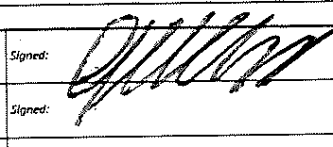

Location:

Date: 2025-02-13

13:39+13:00

Nas Matar

Grant Wallace

13/02/2025

NCR03 raised for Sika Monotop 438R Abutment A Plinth East - For No test cylinders taken.

